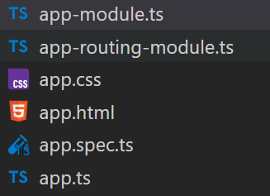
Root module file
Root component UTC file
Root component CSS file
Root component view file
Root component code file

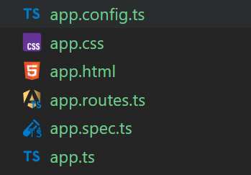
Root component CSS file
Root component view file
Root component code file

